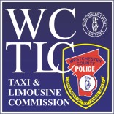

2023 PROM NIGHT FACT SHEET
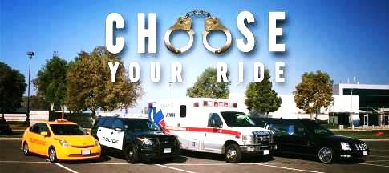

GENERAL
When Hiring a Limousine or Car for the Prom

Ensure the Limousine Company or Car Service, and the driver are all properly licensed with the Westchester County Taxi & Limousine Commission (WCTLC) for pick-ups and drop-offs within Westchester County. Contracts must be signed by persons 18 years or older.
- If going to a prom in Westchester, but being picked up outside of Westchester, ensure the limousine company or car service has vehicles and drivers licensed by either Westchester County TLC, New York City TLC, Nassau County TLC or Suffolk County
- Larger limousines and party buses are not required to have TLC permits but they need to be in compliance with New York State Department of Transportation safety regulations
- The Driver is required to have a valid NY chauffer class license E [up to 9 passengers]
- WCTLC recommends signing a 'prom safety contract' with an authorized TLC Limousine/ Car Service
- Party buses are NOT exempt. Buses will be inspected for alcohol/drugs

PERMITS

Vehicle’s WCTLC Permit
- Cars licensed to do for-hire business in Westchester County will have a rectangular WCTLC decal on the lower right side of the windshield
- The expiration date of each permit is prominently displayed on the permit

Driver’s Permit
- The driver should be able to produce a valid WCTLC driver permit
- The expiration date of the permit will be prominently displayed in RED under the driver’s photo

PROM NIGHT
When the car arrives on prom night, check the following:
- All Westchester County for-hire vehicles that seat fewer than 15 passengers
must be registered with the WCTLC.
- NYS Department of Motor Vehicles requires that a driver of a vehicle that seats 10 or more passengers have a Commercial Driver’s License (CDL)
- Remind the car service that persons under 21 will use the car, and that there should be NO ALCOHOL in the vehicle. Also speak to the driver and reiterate to him/her that he/she is not to provide alcohol, and/or allow the consumption of alcohol by under-aged passengers while riding in the vehicle

For more information, contact the Taxi and Limousine Commission, at
(914) 995-8400 or visit the TLC Website site at: https://tlc.westchestergov.com.

